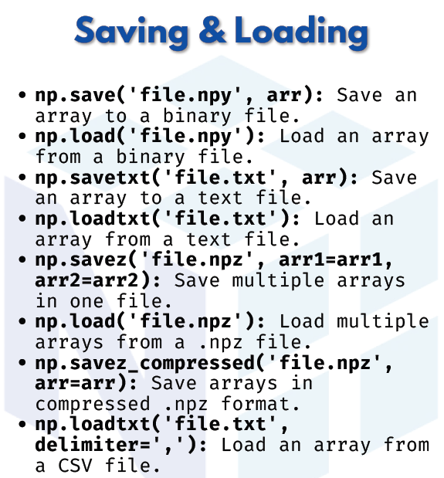

SAVING & LOADING

Binary Files
- np.save('file.npy', arr) → Save an array to a binary .npy file
- np.load('file.npy') → Load an array from a binary .npy file
Text Files
- np.savetxt('file.txt', arr) → Save an array to a text file
- np.loadtxt('file.txt') → Load an array from a text file
- np.loadtxt('file.txt', delimiter=',') → Load array from a CSV file
Multiple Arrays
- np.savez('file.npz', arr1=arr1, arr2=arr2) → Save multiple arrays in one .npz file
- np.load('file.npz') → Load multiple arrays from a .npz file
Compressed Format
- np.savez_compressed('file.npz', arr=arr) → Save arrays in compressed .npz format

